Match the festival with the country:

1. The Day of St. Lazarus

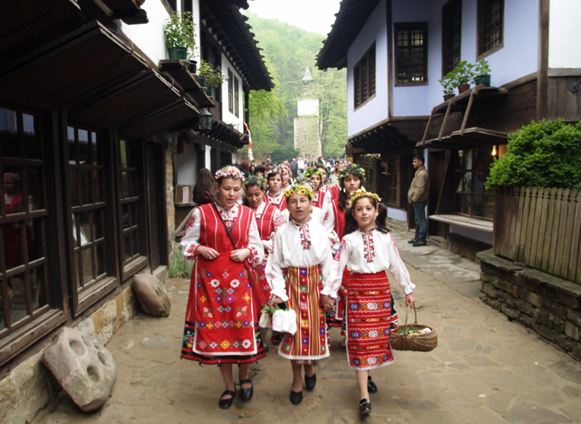

a. Poland

b. Italy

c. Bulgaria

d. Sweden

Answer: c

2. Baba Martha

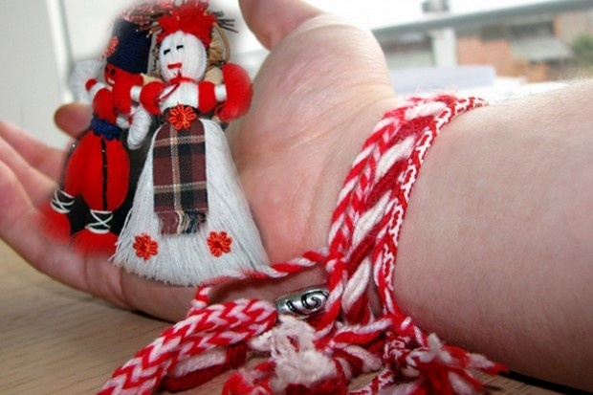

a. Romania

b. Bulgaria

c. Turkey

d. Spain

Answer: b

3. Koleduvane

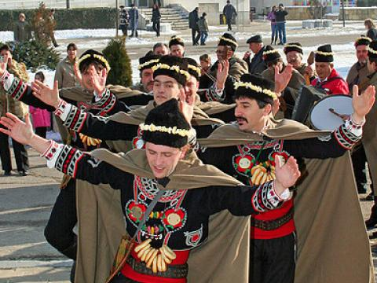

a. Bulgaria

b. Italy

c. Sweden

d. Turkey

Answer: a

4. Kukerov Festival

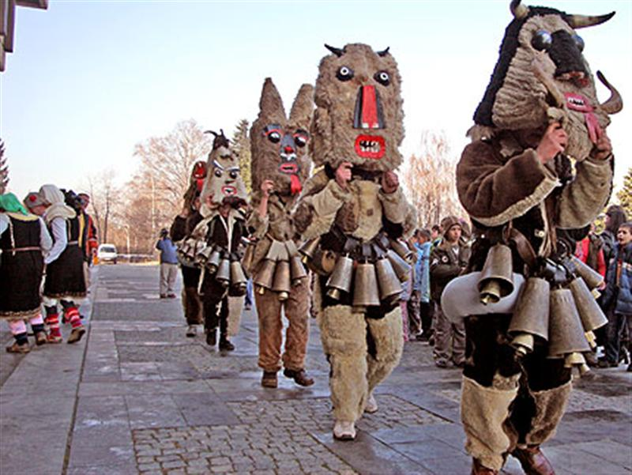

a. Poland

b. Bulgaria

c. Romania

d. Spain

Answer: b

5. Rose festival

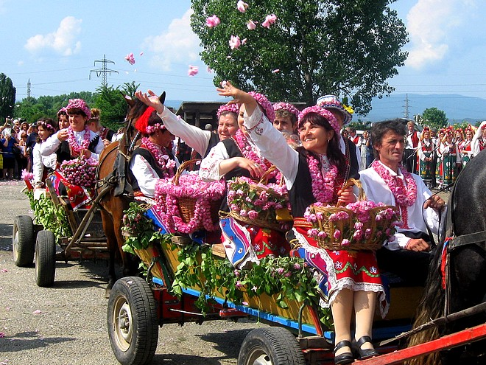

a. Sweden

b. Italy

c. Turkey

d. Bulgaria

Answer: d

**Sources**

**The Day of St. Lazarus**

<http://www.etar.org/kalendar/kal2009/mominski_igri/mominski_igri.htm>

**Grandma Martha Feast**

<http://en.wikipedia.org/wiki/Baba_Marta>

<http://dariknews.bg/view_article.php?article_id=861980>

**Koleduvane**

<http://bg.wikipedia.org/wiki/%D0%9A%D0%BE%D0%BB%D0%B5%D0%B4%D1%83%D0%B2%D0%B0%D0%BD%D0%B5>

<http://www.sibir.bg/index.php?page=displayTopic&id=4073&tid=112900>

**Kukerov Den Festival**

<http://www.burgasinfo.com/news/view/2/21764>

**Rose Festival**

<http://www.rose-festival.com/rose-festival.shtml>

<http://stzagora.net/2012/03/09/%D0%BA%D0%B0%D0%B7%D0%B0%D0%BD%D0%BB%D1%8A%D0%BA-%D1%84%D0%B5%D1%81%D1%82%D0%B8%D0%B2%D0%B0%D0%BB%D1%8A%D1%82-%D0%BD%D0%B0-%D1%80%D0%BE%D0%B7%D0%B0%D1%82%D0%B0-%D0%B1%D0%B5-%D0%BF%D1%80%D0%B5%D0%B7/>